**Exercise 3: Stored Procedures**

**CREATE TABLE Accounts (AccountID NUMBER PRIMARY KEY, AccountType VARCHAR2(20),Balance NUMBER);**

**INSERT INTO Accounts VALUES (1, 'Savings', 10000);**

**INSERT INTO Accounts VALUES (2, 'Savings', 5000);**

**INSERT INTO Accounts VALUES (3, 'Checking', 3000);**

**INSERT INTO Accounts VALUES (4, 'Savings', 8000);**

**COMMIT;**

**Scenario 1:** The bank needs to process monthly interest for all savings accounts.

* + **Question:** Write a stored procedure **ProcessMonthlyInterest** that calculates and updates the balance of all savings accounts by applying an interest rate of 1% to the current balance.

CREATE OR REPLACE PROCEDURE ProcessMonthlyInterest IS BEGIN

UPDATE Accounts

SET Balance = Balance + (Balance * 0.01)

WHERE AccountType = 'Savings';

DBMS_OUTPUT.PUT_LINE('Monthly interest applied to all savings accounts.');

END;

/

EXEC ProcessMonthlyInterest;

**OUTPUT:**

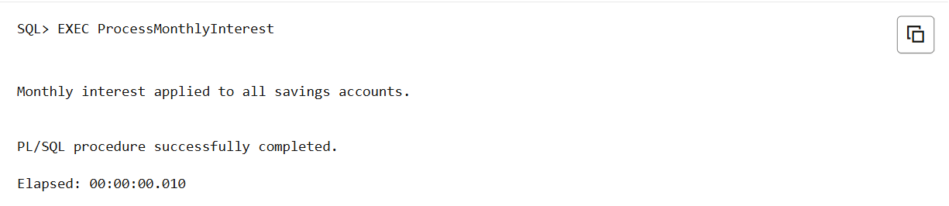

**Scenario 2:** The bank wants to implement a bonus scheme for employees based on their performance.

CREATE TABLE Employees (EmployeeID NUMBER PRIMARY KEY, Name VARCHAR2(100),DepartmentID NUMBER,Salary NUMBER);

INSERT INTO Employees VALUES (101, 'Amit', 10, 40000);

INSERT INTO Employees VALUES (102, 'Bhavitha', 10, 45000);

INSERT INTO Employees VALUES (103, 'Ravi', 20, 42000);

INSERT INTO Employees VALUES (104, 'Suresh', 20, 46000);

COMMIT;

* + **Question:** Write a stored procedure **UpdateEmployeeBonus** that updates the salary of employees in a given department by adding a bonus percentage passed as a parameter.

CREATE OR REPLACE PROCEDURE UpdateEmployeeBonus (

p_DepartmentID IN NUMBER,

p_BonusPercent IN NUMBER

) IS

BEGIN

UPDATE Employees

SET Salary = Salary + (Salary * p_BonusPercent / 100)

WHERE DepartmentID = p_DepartmentID;

DBMS_OUTPUT.PUT_LINE('Bonus applied to Department ' || p_DepartmentID);

END;

/

EXEC UpdateEmployeeBonus(10, 10);

OUTPUT:

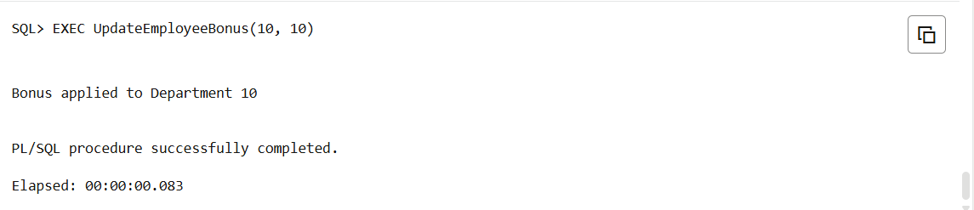

**Scenario 3:** Customers should be able to transfer funds between their accounts.

* + **Question:** Write a stored procedure **TransferFunds** that transfers a specified amount from one account to another, checking that the source account has sufficient balance before making the transfer.

CREATE OR REPLACE PROCEDURE TransferFunds (p_SourceAccountID IN NUMBER,p_TargetAccountID IN NUMBER,p_Amount IN NUMBER)

IS

v_SourceBalance NUMBER;

BEGIN

SELECT Balance INTO v_SourceBalance

FROM Accounts

WHERE AccountID = p_SourceAccountID;

IF v_SourceBalance < p_Amount THEN

RAISE_APPLICATION_ERROR(-20001, 'Insufficient funds.');

END IF;

UPDATE Accounts

SET Balance = Balance - p_Amount

WHERE AccountID = p_SourceAccountID;

UPDATE Accounts

SET Balance = Balance + p_Amount

WHERE AccountID = p_TargetAccountID;

DBMS_OUTPUT.PUT_LINE('₹' || p_Amount || ' transferred from Account ' || p_SourceAccountID || ' to Account ' || p_TargetAccountID);

END;

/

EXEC TransferFunds(1, 2, 1000);

**OUTPUT:**

